**Prerequisite**

**IBM Cloud Service**

|  |  |
| --- | --- |
| Team ID | PNT2022TMID14849 |
| Project Name | Smart Farmer- IoT Enabled Smart Farming Application |

**IBM Account Dashboard**

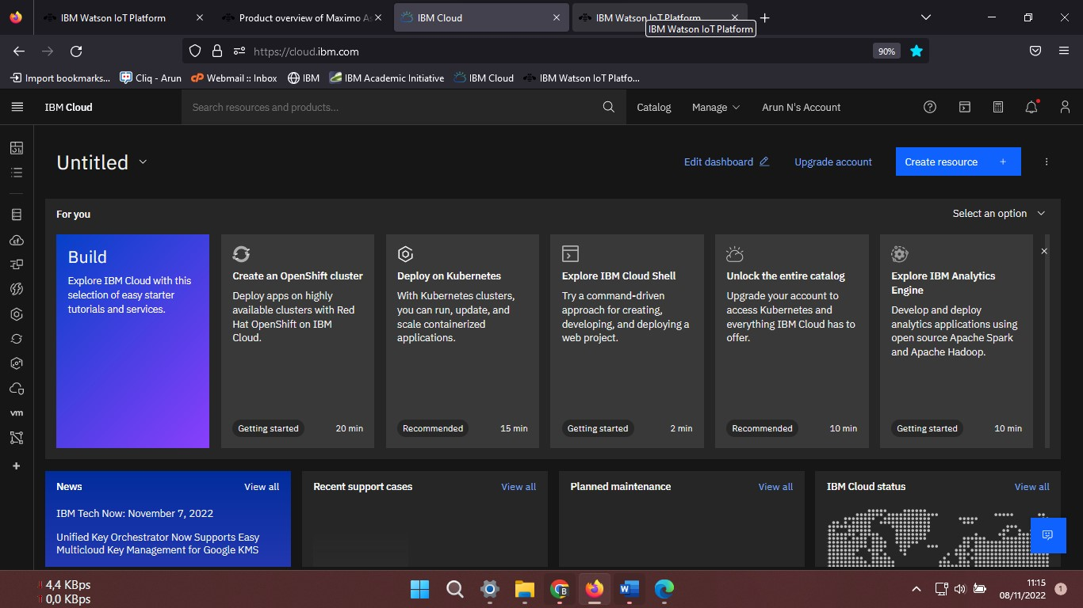

**IBM Watson IoT Platform**

